The American Society of Military Comptrollers
and our
Corporate Advisory Group
cordially invite you to attend our

ASMC Corporate Breakfast
Our guest speaker is Hon. Alan Shaffer, Deputy Under Secretary of Defense for Acquisition and Sustainment.

Following our speaker, we will have an update from the ASMC Executive Director, Al Runnels.

Wednesday, 20 November 2019

From 7:00 to 9:00 AM

Army Navy Country Club

Nimitz Room

1700 Army Navy Drive

Arlington, VA 22202
Gold corporate members may register four individuals.
Silver corporate members may register two individuals.
Bronze corporate members may register one individual.

Please click here to register for the breakfast. Registration deadline is Friday, 15 November 2019.

Please contact Donna Pumphrey (pumphrey@asmconline.org) with any questions.

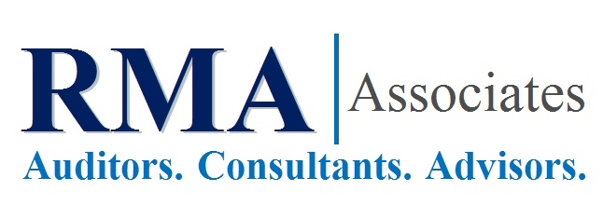
This Corporate Breakfast event is made possible thanks to our generous sponsor,
RMA Associates.

