Fred A. (Al) Runnels
Executive Director, American Society of Military Comptrollers

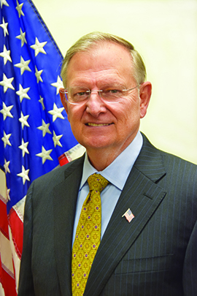
Mr. Runnels assumed his duties as Executive Director of ASMC on October 1, 2012. He leads ASMC programs and operations devoted to supporting the defense financial management community regarding training, professional development, certification, and ethics.

He has over 35 years of service to the United States government, including approximately 10 years at the Senior Executive Service level.

During his 27-year career on active duty in the US Army, Mr. Runnels commanded at company, battalion, and brigade levels. He also served as the Chief of the Operations Branch within the J-8 Directorate of The Joint Staff at the Pentagon. He served as the first commander of the 18th Soldier Support Group (Airborne) at Fort Bragg, NC, which also included responsibilities as the XVIII Airborne Corps Finance Officer, Corps Adjutant General, and Commander of the North Carolina Area Casualty Command.

Mr. Runnels deployed to Baghdad, Iraq in 2003 and served in dual roles as Chief of the Pentagon/Coalition Provisional Authority Management Liaison Cell and as Chief Financial Officer of the Coalition Provisional Authority.

Mr. Runnels served for three years as the Deputy Chief Financial Officer of the Department of the Treasury. He also served within Treasury as the Acting Deputy Director of the United States Mint, supporting the Mint Director in managing the HQ in Washington, DC and in overseeing operations of the Mints in Denver, Philadelphia, San Francisco, and West Point, as well as the United States Bullion Depository at Fort Knox. Prior to his assignments with the Department of the Treasury, he served in positions as the Director of Standards and Compliance and the Deputy Director, Military and Civilian Pay Services within the Defense Finance and Accounting Service.

He was a founding Board member of the Association of Federal Enterprise Risk Management, which is devoted to promoting the application of ERM within the federal government and served on the Board for four years, including service as President from 2013 to 2014. He is also a Fellow of the National Academy of Public Administration.

A 1974 graduate of Mississippi State University with a degree in accounting, Mr. Runnels also received an MBA from Syracuse University and a Masters of Strategic Resources Management from the Industrial College of the Armed Forces. He holds certificates as both a Certified Defense Financial Manager (CDFM-A) and a Certified Government Financial Manager (CGFM).

Mr. Runnels and his wife Kathy have three children and six grandchildren.

