Special thanks to our event sponsor:

American Society of Military Comptrollers
415 N. Alfred Street
Alexandria, VA 22314

Phone: (703) 549-0360 or (800) 462-5637
Fax: (703) 549-3181
www.asmconline.org

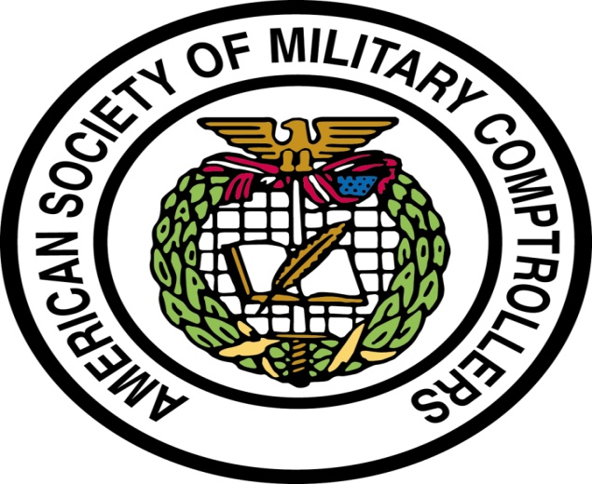

Corporate Breakfast

20 November 2019

Army Navy Country Club
Arlington, VA

Sponsored by

American Society of Military Comptrollers
welcomes you to the
ASMC Corporate Breakfast

0700 Check-In

0715 Breakfast Buffet

0740 Welcome and Introductions
Ms. Debra Del Mar
Chair
ASMC National Corporate Advisory Group

0750 Guest Speaker
Hon. Alan Shaffer
Deputy Under Secretary of Defense for Acquisition and Sustainment

Questions and Answers
Hon. Alan Shaffer

0845 ASMC National Update
Mr. Al Runnels, CDFM-A
Executive Director
ASMC

0900 Adjourn

Guest Speaker
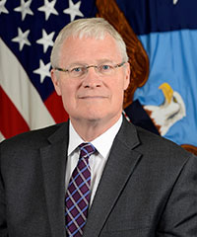
Mr. Alan R. Shaffer currently serves as the Deputy Under Secretary of Defense for Acquisition and Sustainment (A&S). Senate confirmed in January 2019, he is responsible to the Under Secretary of Defense for all matters pertaining to acquisition; contract administration; logistics and material readiness; installations and environment; operational energy; chemical, biological, and nuclear weapons; the acquisition workforce; and the defense industrial base.
Mr. Shaffer previously served as the Principal Deputy Assistant Secretary of Defense for Research and Engineering (ASD(R&E)) where he was responsible for formulating, planning and reviewing the DoD Research, Development, Test, and Evaluation (RDT&E) programs, plans, strategy, priorities, and execution of the DoD RDT&E budget that totals roughly $25 billion per year. He has also served twice as the Acting Assistant Secretary of Defense for Research and Engineering.
Mr. Shaffer holds a Bachelor of Science in Mathematics from the University of Vermont, a second Bachelor of Science in Meteorology from the University of Utah, a Master of Science in Meteorology from the Naval Postgraduate School, and a Master of Science in National Resource Strategy from the Industrial College of the Armed Forces. He was awarded the Meritorious Executive Presidential Rank Award in 2004, the Department of Defense Distinguished Civilian Service Award, and the Distinguished Executive Presidential Rank Award in 2007 and 2015.

