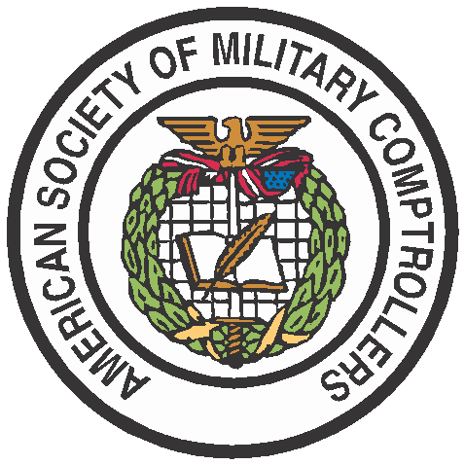
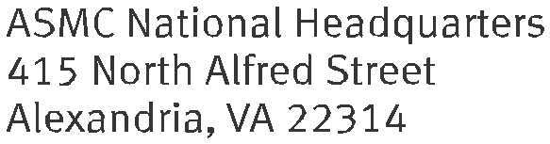

PRESS RELEASE
FOR IMMEDIATE RELEASE Media Contact: Melissa Blacketer
(703) 549-0360
blacketer@asmconline.org

ASMC Announces the Planning, Programming, Budgeting, and Execution (PPBE) Reform Task Force Members

Alexandria, VA (June 28, 2022) –The American Society of Military Comptrollers (ASMC) has announced the initial members of the PPBE Reform Task Force.

The PPBE Reform Task Force is responsible for increasing awareness and fostering public discussion on PPBE reform in the Department of Defense. Operating in parallel with the Legislative Commission on PPBE Reform, the Task Force will work to define a set of fundamental principles and policy actions to reimagine PPBE to meet the needs of the Executive Branch, the Legislative Branch, and industry in the 21st century.

The Task Force members are:
- Michael Conlin (Chair) – Definitive Logic Corporation
- Charles Cook – Government & Public Services, Deloitte
- Lasheeco Graham - Assistant Administrator for Budget, FEMA
- Honorable Tom Harker – Former Assistant Secretary of the Navy (FM&C), Acting Under Secretary of Defense Comptroller/CFO, and Acting Secretary of the Navy
- Cameron Holt, Holt Consulting Group LLC
- George E. Kovatch, Kovatch Advisors, LLC, Former Deputy Comptroller, DoD
- Robert “Mike’ Maxwell – Department of the Army (Retired SES), Former VP, SAIC
- Jim Palmisano - Regional Vice President, Oracle
- Dr. Michael A. Parker - VP, Salesforce, USMC (Retired)
- Vance Stewart - Department of the Army (Retired)
- Vice Admiral Pat Tracey – U.S. Navy (Retired)
- Lieutenant Colonel Neville Welch - USMC (Retired), Independent Consultant, EOP Foundation

These experienced members of the Task Force possess a balance of perspectives and backgrounds related to financial management, strategic planning, procurement and acquisition management, change management, information technology, and data science in government and the private sector.
“The work of the Task Force is critical to improving the resource allocation process in the Department of Defense to meet the needs of government, taxpayers, and warfighters.” Rich Brady, CEO ASMC and PPBE Reform Task Force sponsor.
“We have a once-in-a-career opportunity to help the DoD lift its game in great power competition.” Michael Conlin, CTO Definitive Logic, Task Force Chair
The initial meeting of the Task Force will take place on July 7, 2022, at ASMC headquarters in Alexandria, VA.
About ASMC:
ASMC, established in 1948, is the non-profit educational and professional organization for persons, military and civilian, involved in the overall field of defense financial management. ASMC promotes the education, training, and certification of its members, and supports the development and advancement of the defense financial management profession. The Society provides professional programs to keep members abreast of current issues and encourages the exchange of information, techniques, and approaches.
###

